BETTY KOUADIO

Professor: Dr. Robert Alexander

Assignment- Assignment#5

**Reflection**

In the assignment 5, we are asked to convert Morse code to English

character. For this we will create and build class Tree and all its components.

This assignment has helped me learn more about Morse code and its algorithm

which is very simple. Every character in the English language is substituted by a

series of ‘dots’ and ‘dashes’ or sometimes just singular ‘dot’ or ‘dash’ and vice

versa. Every text string is converted into the series of dots and dashes. For this

every character is converted into its Morse code and attached in encoded

message.

**Screenshot**

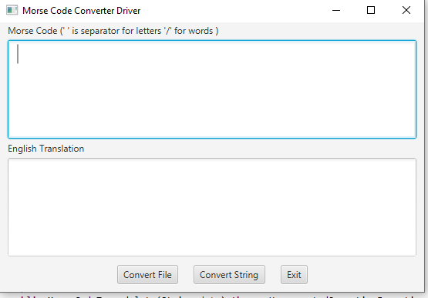

Daisy

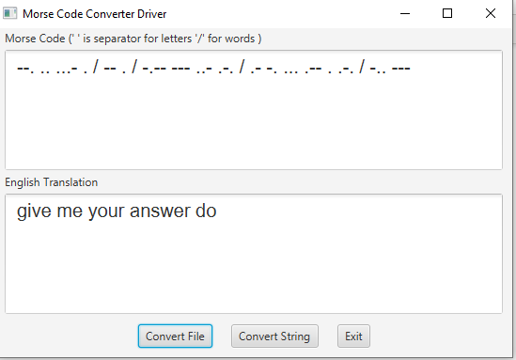

DaisyDaisy

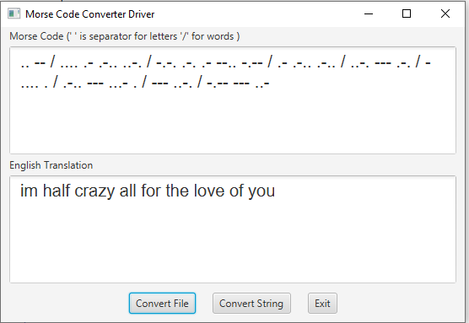

howDoIloveThee

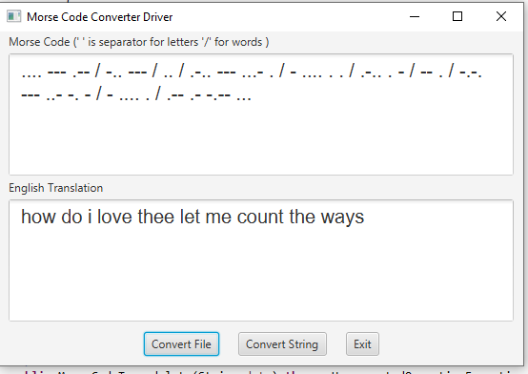

LoveLooksNot

